# TCP/IP Attack Lab

57117217戚吴祺

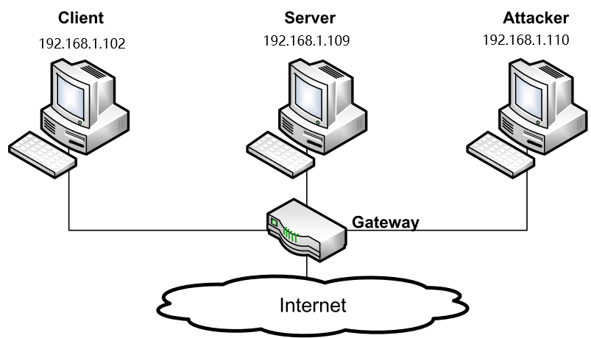

Environment Setup Above

Kali

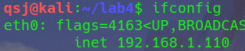

Ubuntu（Seed）

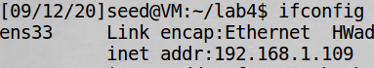

Windows10（host computer）



### Task 1: SYN Flooding Attack

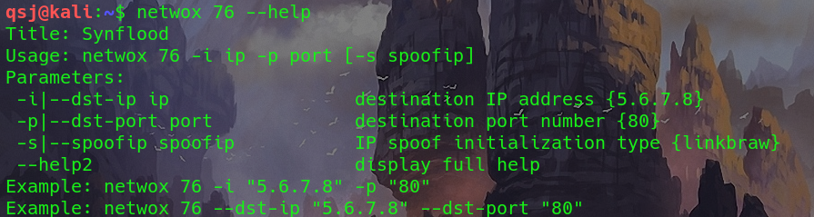

**$ sudo sysctl -w net.ipv4.tcp_syncookies=0 (turn off SYN cookie)**



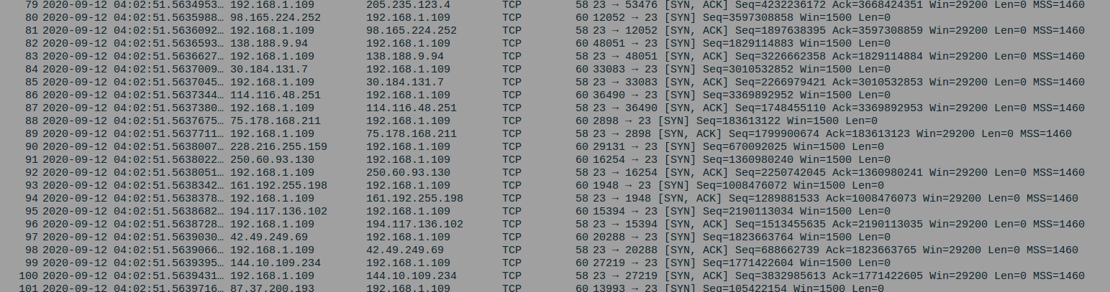

攻击开始

由于SYN Cookie Countermeasure 开启，telnet依旧连接成功

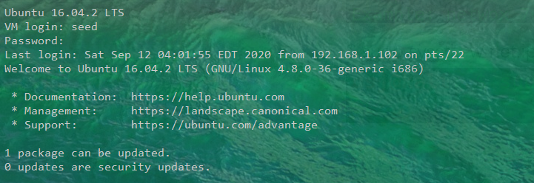

**$ sudo sysctl -w net.ipv4.tcp_syncookies=1 (turn off SYN cookie)**

由于SYN Cookie Countermeasure 关闭，telnet 连接失败



### Task 2: TCP RST Attacks on telnet and ssh Connections

#### Using netwox

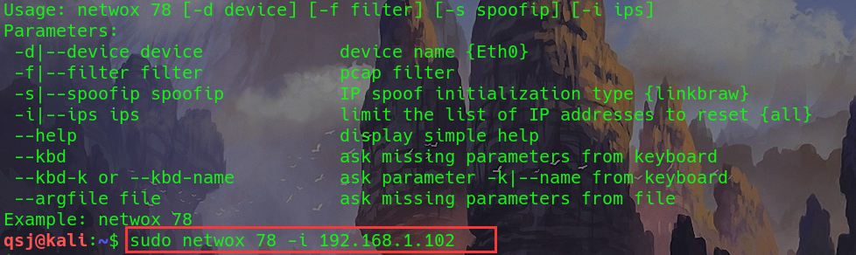

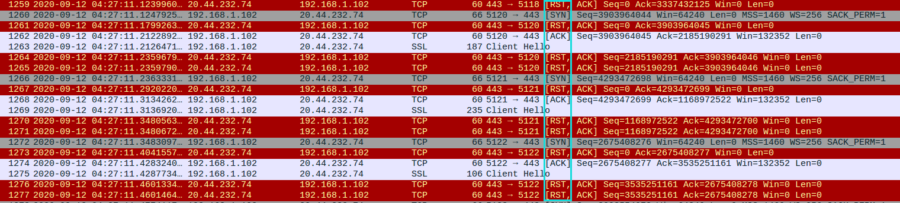

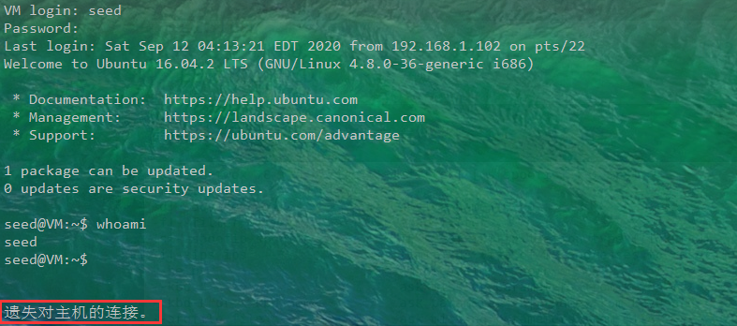

telnet断开连接，攻击成功





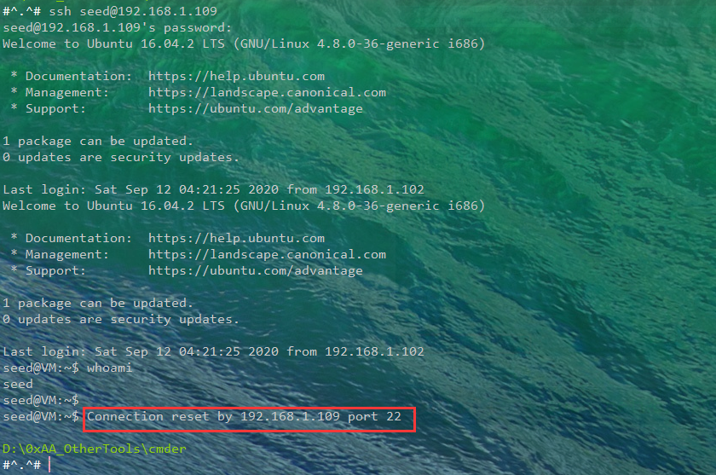

ssh断开连接，攻击成功

#### Using scapy

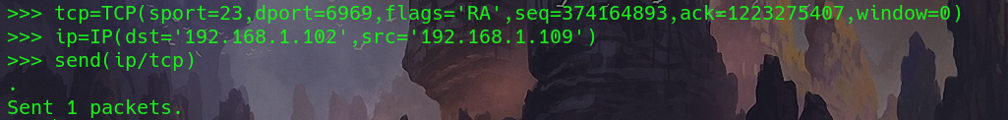



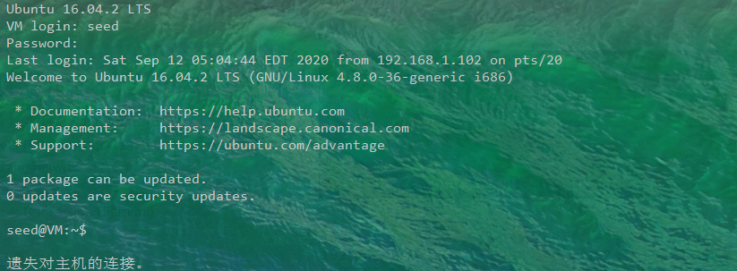

### Task 4: TCP Session Hijacking

